HMD launches Cathy plus Safety IV Cannula with SIP CLIP: the next generation Safety I.V. Cannula for preventing Needle Stick Injuries

Dubai: Hindustan Syringes and Medical Devices Limited (HMD) - world’s leading and India’s largest manufacturer of auto disabling and single use syringes - today launched Cathy Safety IV Cannula with SIP CLIP: the next generation safety intravenous Cannula at the Arab Health Exhibition & Summit here.

The innovative, state-of-the-art Cathy+ Safety IV Cannula with SIP CLIP is designed to minimize risks associated with needle stick injuries common among healthcare staff and workers which have been a major cause of transmission of blood borne viruses such as HBV, HCV and HIV among other health risks.

“Our next generation cannula offering Cathy+ Safety IV Cannula with SIP CLIP is designed not only to minimize health risks associated with accidental needle injuries but will also help bring down substantially the overall cost resulting from treatment of diseases due to needle injuries and resultant nosocomial infections” said Mr. Rajiv Nath, Joint Managing Director of Hindustan Syringes and Medical Devices Limited (HMD) at the launch.

Cathy+ Safety IV Cannula with SIP CLIP is a world patented first Needle Protection Device’ in a pure polymer with a catheter that is proprietary polyurethane (VOLEX). It is loaded with innovative safety features such as ‘Auto Protection Safety Mechanism - so no activating or secondary action is required by user’; the safety clip Fits accurately in huer chamber and product Feels and functions like a standard IV Catheter with no need for training for deploying this. Cathy+ Safety IV Cannula with SIP CLIP has precisely designed bump on needle and its safety mechanism is activated automatically on withdrawal of needle post Cannulation.

Some of the innovative features of Cathy+ Safety IV Cannula with SIP CLIP include:
- Automatic Passive Safety
- SIP - Sharps Injury Prevention.
- Injection molded in one piece – cost advantage
- The First Needle Protection Device in a pure Polymer, which is integrated inside the Catheter Adapter
- Safe, simple and customer – friendly
- Ease of insertion without peel back
- Minimal Trauma
- Ultra sharp, ultra polished needles
- Electro polished and back-cut point

It may be pointed that needle-stick injuries are common among healthcare staff and workers. Nurses are the largest single group, and have high rates of injury. According to WHO, 80% of all hospital staff have personally experienced needle stick injuries, There are 2 million reported needle stick injuries per EU and US, plus more than 1 million unreported injuries. Out of 35 million Heath Care workers nearly 10% receive percutaneous exposure to blood borne pathogens like Hepatitis and HIV annually and 90% of these accidents occur in developing countries. The risk of becoming infected by a needle that has been in contact with a HIV positive patient is 0.5%, for Hepatitis B it is 20% and for Hepatitis C it is 5%. Needle stick injuries also result in high financial and human costs and cause considerable distress to Nurses and Doctors.

To mitigate the risks, within EU, safety devices are mandatory as of May 11, 2013 (EU Council Directive 2010/32 of May 10, 2010) and USA passed “Needle stick Safety and Prevention Act (NSPA)” in 2000.

About HMD: Founded in 1957, HMD is India’s leading medical device manufacturer with offices in USA and UK and has annual turnover of approximately US$ 100 million. It is also market leader of I.V. Cannula & Syringes & Needles in India. HMD has eight highly automated plants employing over 3500 people and has a customer base of over 4000 dealers. HMD’s primary international markets are USA, Europe and Middle East. All its products are manufactured as per ISO 9001, ISO 13485, and the European M.D.D. & US FDA standards. Besides being Jt. Managing Director of HMD, Mr. Rajiv Nath is also Forum Coordinator of Association of Indian Medical Device Industry (AIMED).

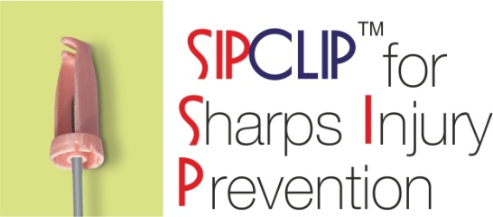
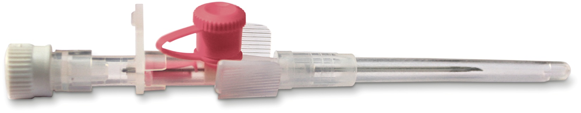
GL-3, Ashoka Estate, 24, Barakhamba Road, New Delhi - 110 001
Ph. +91-129-4289000/4061151, Fax. +91-129-4061164 & 2233242
E-mail: hmduk@hmdhealthcare.com, Web: www.hmdhealthcare.com

